Answers to the Assignment

The Correction Term is Highlighted and Word to be replaced is written besides “Answer:”

1. I wish to read your best seller, could you send me the same?

Answer: would

1. Open your shoes.

Answer: Take Off/Remove

1. Close the fan.

Answer: Switch Off

1. If he is hard working means he will succeed.

Answer: hard worker then

1. My brother in laws are coming for the wedding.

Answer: attending

1. It is different time.

Answer:

1. We did it like that only.

Answer: Don’t Use Only

Many of us have a habit of ending sentences with the word “only,” for example, “I took it from there only.”

This is actually a grammatical error- it is a direct translation from the sentence structure of the same phrase in Indian languages, such as:

Hindi: “Maine wahi se le liya tha.”

Malayalam: “Njan avadenn thanne eduthu.”

Tamil: “Naan angendu thaan eduthen.”

1. Let us prepone the meeting.

Answer: advance

I bet you’re surprised to see this on the list. Prepone is a perfectly legit word, you think. Prepone is the opposite of postpone, you think. In reality though, prepone is an Indianism. It was conjoined by English speakers in India and had never existed in the English language before we started saying it. The correct phrase is to “advance.” So, instead of “can we prepone the meeting to 2 PM?” you should say, “can we advance the meeting to 2 PM?”

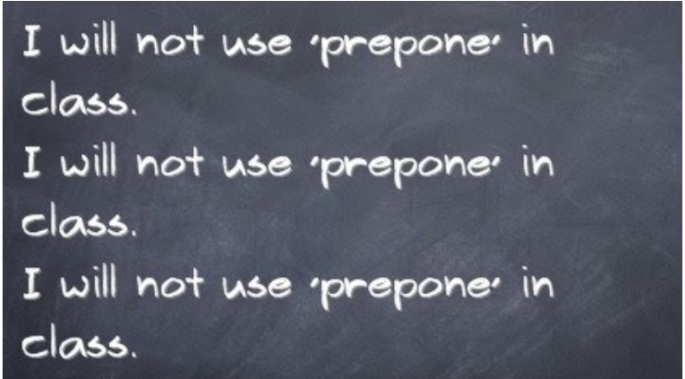

1. The boss is phoning.

Answer: attending a phone call

1. Please do the needful. (Desi Email Signoff)

Answer: do what is necessary / Thank you for your time

If you’ve said that in your email, do not, we repeat DO NOT write this. If you’re stuck, just write ‘Thank you for your time’ instead or repeat the action you want completed like ‘Please send the details by 10.30 am.’

“Do the needful” is meant to refer to doing what is necessary, but it is -- again -- only used in Indian English. The rest of the world says “do what is necessary.”

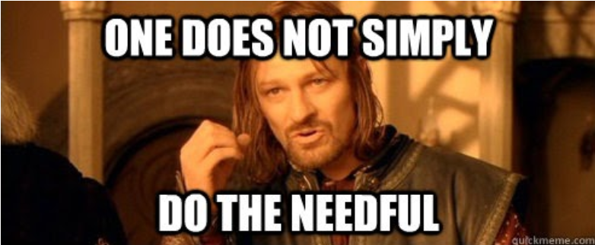

1. My cousin brother arrived from Texas.

Answer: cousin

In English, we distinguish between a brother - a man who has the same parents, or at least one of the same parents, as you do - and a cousin - someone who is the child or grandchild of a brother or sister of one of your parents or grandparents.* We never lump the two types of relationship together into a single term.

1. I passed out of college last year.

Answer: graduated

1. Where are you put up?

Answer: *Someone who wants to know where do you stay (in which area of a city).*

1. You asked her, no?

Answer: Do not Add “No?” Unnecessarily

*A tendency to add “no” before the end of every question.*

1. You could have literally not me down with a feather.

Answer: knocked

## Idiom: knocked me down with a feather: Means you were extremely surprised or shocked by something

1. He does this always I received the parcel today morning.

Answer: today in the morning

1. He will come by walk.

Answer: reach walking.

Hindi speakers tend to say “I’ll come just now,” which is a direct translation of “Main abhi aata/aati hoon,” which is how the same sentiment is expressed in Hindi.

1. What is your good name? (Desi Conversation Starter)

Answer: *What’s your name? – transliteration from Hindi()*

Have you heard a bad name before? I’m guessing the answer is never. The next time you are tempted to say that, say this instead: “What’s your name?”

1. Do this or i will give you a tight slap.

Answer: I will give you a Tight Slap if you didn’t do this Task.

1. His marriage is on 3 September.

Answer: scheduled on

1. Time is over, please submit your answer books.

Answer: book

1. The lesson is delivered today.

Answer: will be

1. The principle hoisted the flag.

Answer: No Error

1. There was pin drop silence in the room.

Answer: No Error/pin drop not required

1. He returned home yesterday evening.

Answer: yesterday

1. Please walk on the footpath.

Answer: the not required

1. My uncle expired last week.

Answer: is no more and died

People don’t have Expiry Date.

1. We mourn the sad demise of our leader.

Answer:

1. She is carrying.

Answer: caring

1. Meet my better half.

Answer: Wife/Husband

1. This is my mrs.

Answer: Wife/Spouse

1. I have to see somebody at 5:15.

Answer: attend someone

1. How do you do?

Answer: What

1. Between 1947 to 1967 many academic institutions were opened in India. Answer: From 1947 to 1967
2. I welcome the august audience.

Answer: audience for the august gathering.

1. The colony in which I live is nearby.

Answer: I live in nearby Colony.

1. We decided to have lunch in the new hotel.

Answer: No Error as Such

1. They are my co- brother and co-sister.

Answer: co- brother-in-law and co-sister-in-law

1. You can meet the patient when he comes to his senses.

Answer: is conscious.

1. The puppy climbed the stairs itself only.

Answer: Don’t Use Only

Have you ever asked yourself what is the purpose of adding ONLY to a sentence? Is it for additional stress?

As tempted as you may be, put a ban on using the word “only” liberally in your sentences. “Only” must be used only in the right places like “I’ve got only these receipts” meaning those are the ones you have and not any other, or “I’ve only spoken to her” meaning I’ve spoken only to that girl and not any other.

1. The movie was too good.

Answer: extremely

1. Did you give the exam?

Answer: take the exam

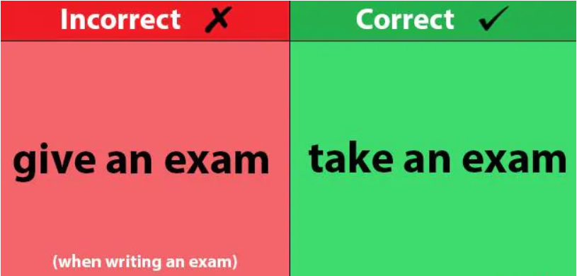

1. Kindly revert back.

Answer: revert

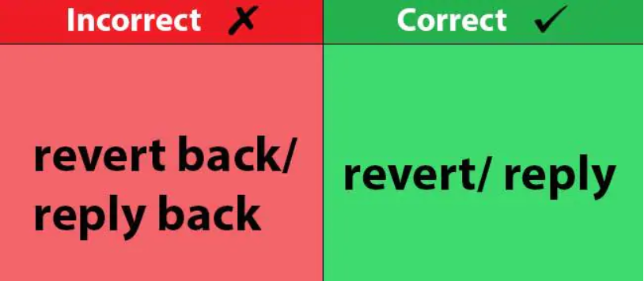

1. It is very cold, switch on the heater.

Answer: turn

1. She won’t be able to cope up with strangers.

Answer: cope with

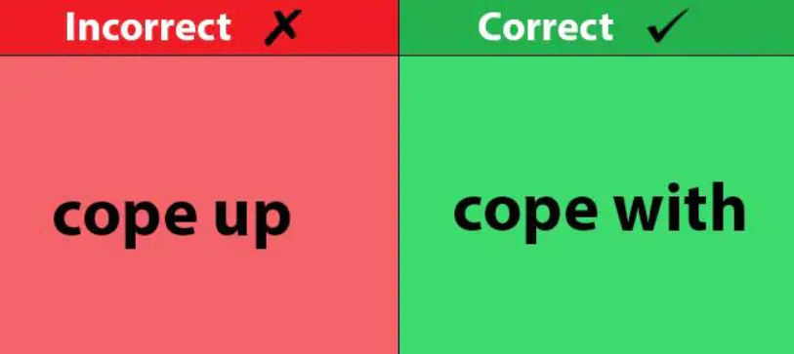

1. Myself, Mr. P. Kumar. (Desi Introduction)

Answer: If you are introducing yourself, the best way to do it would be to say, “I am Mr. P. Kumar.”

This is because Myself is only used if you’ve already said I and you are referring to yourself again. For instance, I hurt myself accidentally. So, that way of introducing yourself is completely wrong.

1. Anyways, let’s get back to work.

Answer: Anyway

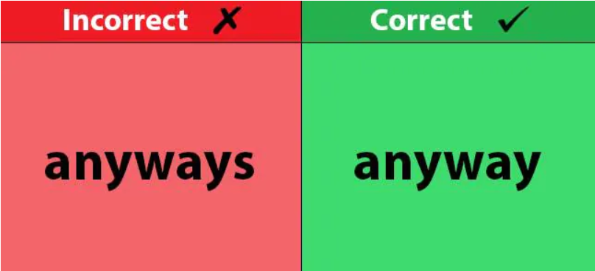

1. Many a times, I wish I hadn’t written that mail.

Answer: Many times/many a time

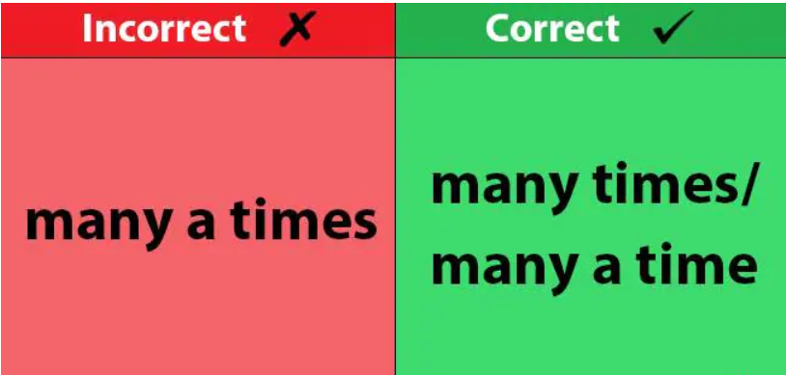

1. He won a prize in debate competition.

Answer: debate

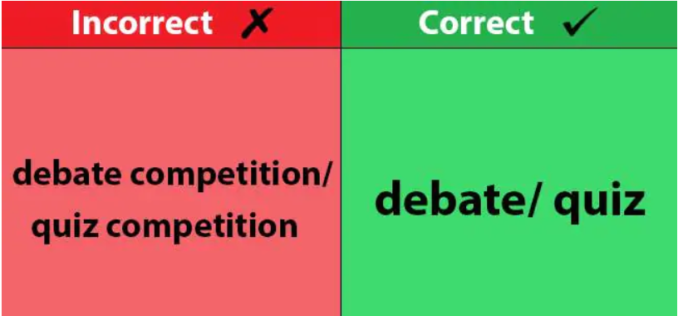

1. He is like that only.

Answer: Don’t use only

1. I am working in SVNIT.

Answer: at

1. When did you pass out?

Answer: graduate from

A visiting aunt just asked me, “What year did you pass out from college?” I’ll admit that I had a wild time in college and literally passed out several times too many, but using “pass out” to mean “graduate from” is not correct English.



1. I saw a dream?

Answer: had a dream/Did I Saw a Dream?

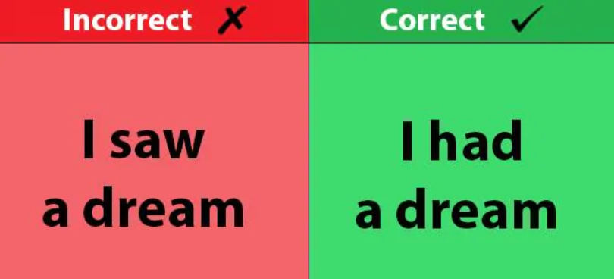

1. My cousin sister is coming this weekend.

Answer: cousin (Don’t Mix two Relation)

1. I will see you today afternoon.

Answer: afternoon

1. Have you seen this film?

Answer: watched that

1. What is this called as?

Answer: called

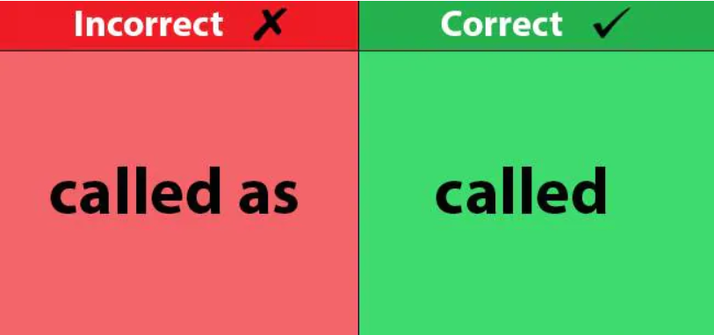

1. I am giving the exam.

Answer: taking

“When are you giving the board exams?” “Are you going to give the SATs?” The correct word is “take.” You take the board exams. You take the SATs. You can also say sit the exams.

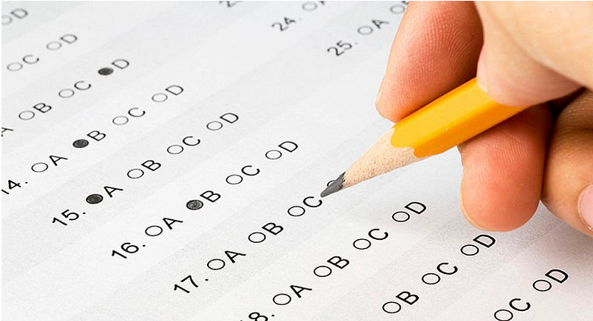

1. Today is their marriage anniversary.

Answer: wedding anniversary

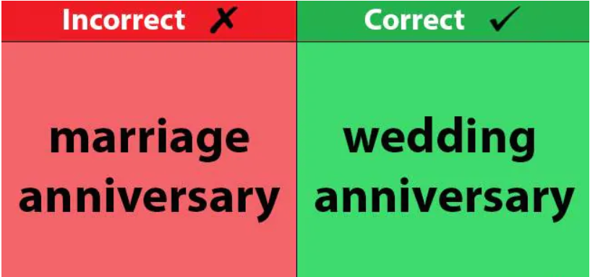

1. I went to her marriage.

Answer: attended

1. Please return my paper back.

Answer: back is redundant/not required

1. Could you repeat that last point again?

Answer: Could you repeat that last point?

1. I will revert back to you shortly.

Answer: revert



1. Get down from the bus.

Answer: off/deboard

1. Off the light before you moves out.

Answer: Turn the Light Off

1. She had a strong Biodata and jack.

Answer: recommandation

1. I will purchase a house soon.

Answer: in one month.

1. I dare you to say it on somebody's face.

Answer: If you dare, then

1. She came home years back.

Answer: years ago

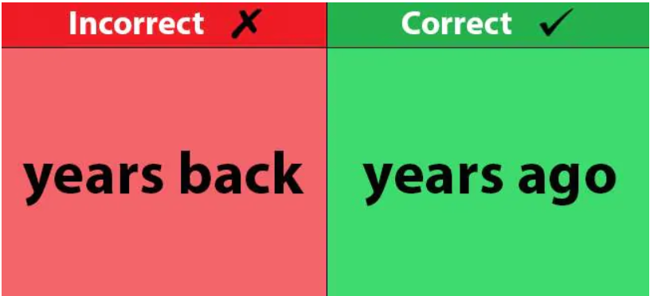

1. Her dressing sense is inappropriate.

Answer: dress sense

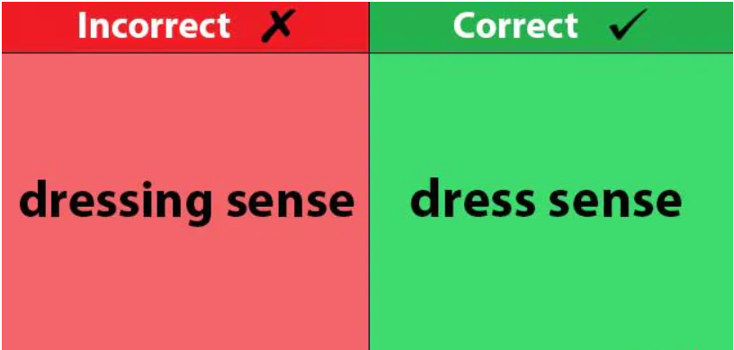

References :

1. <https://www.indiatoday.in/education-today/grammar-vocabulary/story/30-common-english-mistakes-by-indians-318606-2016-04-18>
2. <https://www.thecitizen.in/index.php/en/NewsDetail/index/8/3186/Ten-Common-Incorrect-Indianisms-That-You-Need-To-Stop-Saying>
3. <https://www.edtimes.in/indianisms-grammatical-errors-in-indian-english-that-are-a-direct-translation-from-our-native-tongues/>
4. <https://blog.steptest.in/7-desisms-we-guilty/>
5. <https://commonenglisherrors.com/common-english-mistakes-indians/>

I may have done Some Error in the above sentences (will correct them after Discussion).

Submitted To:

EPC Faculty – Pratima Mam

By:

D- Division

Bhagya Rana (U19CS012)